**Brandon Hobbs**

**CS-360**

**January 9, 2023**

**Project One Prep Writing Prompt**

For Project One I am choosing to implement a Weight Tracking App, option 3. This app will allow multiple users to create a time-bound weight goal. There will be no assumption that the weight goal is one of loss; after all, the user may be a boxer coming up to his fighting weight.

Upon opening the app, the user will be greeted by their name with a message showing pertinent data. For example, this data might include:

* Last app opening date and time
* Last time recording a weight
* Time remaining within the time-bound goal
* Delta between goal weight and last recorded weight

There would also need to be a way to dismiss this pop-up message.

After this message is closed one might expect a simple table to be present that shows a tabular view of data. Above this table could be the control buttons. An example layout is shown below:

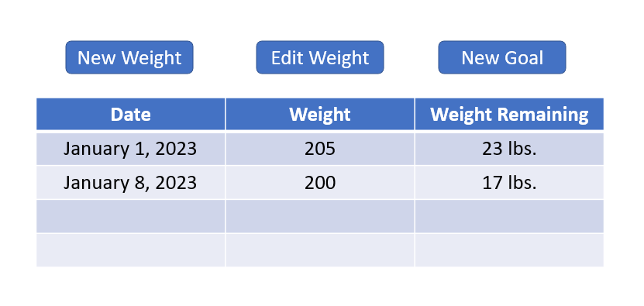

This user data will be stored to the internal phone storage. This user will need to login via a username and password to use the app. More than one user will be allowed to use the app, the database will be multitenant, however.

Upon searching the Google Store for “weight tracker” quite a few competitor apps are available. As a means of competitive analysis “Simple Weight Tracker” and “Weight Tracker” were reviewed.

“Simple Weight Tracker” greets the user with a small summary table showing actual weight, change, the weekly trend, this week’s and this’s months change, and the total weight change. Also, there is a plot with time on the X-axis and weight on the y-axis. A user is also able to set a goal and reminders to enter their weight for the day.

“Weight Tracker” goes a little further. Not only does it have all of the features of “Simple Weight Tracker” it adds prediction ability (trying to predict when the goal will be reached), time spent on the user journey, and BMI tracking.

Neither of these apps appear to allow multiple users to track their goals and weight not do they have any protection on the data – which will be the selling point of this app over its closest rivals.

The types of users who might use an app such as this would fall into two classes: those wanting to lose weight and those wanting to gain weight. All features should work equally well for either class of user. In a day, the user will have very little interaction with the app but at key moments, e.g., morning ablutions, there will be data entry, review, and editing. During these brief interactions data entry should involve as few clicks as possible. The design hypothesis is that the user will spend most time reviewing data instead of entering and editing data.

Lastly, once the user reaches their goal, they should be made aware. Moreover, they may want to share that so there could be an option to easily share this moment with anyone they choose.